1: Hair Affair!: Donated by The Horter Family
Paul Mitchell Extra-Body Daily Boost Root Lifter, Finishing Spray, Shampoo and Daily Rinse, Hairbrush, Chapstick, Scarf, Beauty Pinups Pin Curl Iron
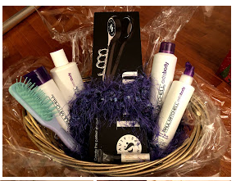

2: We’ve Got the Beat(s):
$25 I-Tunes Gift Card, Ur Beats by Dr Dre Earbuds
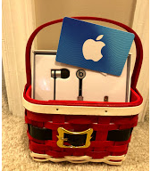

3: ‘Twas the Night Before Christmas:
Throw Blanket, 4 Pairs Christmas Socks, How the Grinch Stole Christmas Movie, Christmas Mad Libs,
“I Saw Santa In Maryland” Book, Gingerbread House Kit, Hot Chocolate, 4 Mugs, Candy Cane Spoons, Christmas Marshmallows
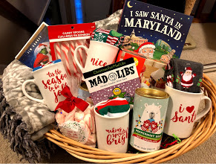

4: A Night in Rome: Donated in part by The Horter Family
Risotto Kit, Stainless Steel Soap, Tuscan Bread Dipper Oil, 2 Red Wine Glasses, Bottle of Kendall-Jackson Cabernet Sauvignon, Vacuum Wine Saver, Mixed Olives, Tomato Basil Sauce, Pappardelle Pasta, Apron, Adult Mad Libs, Stoneware Baking Dish, Pink Himalayan Salt Grinder
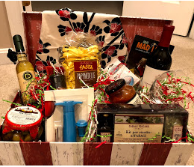

5: Let’s Make Up: Donated by Amy Rinius
Mary Kay Time Wise Repair Volu-Firm Set, Time Wise Repair Revealing Radiance Facial Peel, Clear Proof Deep-Cleansing Charcoal Mask, Skinvigorate Cleansing Brush, Satin Body Indulgent Shea Body Wash, Satin Body Indulgent Shea Body Lotion, White Tea & Citrus Satin Hands Pampering Set, Satin Lips Set, Discover What You Love Travel Roll Up Bag, Spa Headband
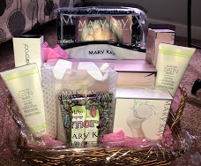

6: Morning Boost: Donated by The Delvalle Family
Special Edition Espresso Roast Coffee, Pike’s Place Decaf Coffee, Guatemala Casi Cielo Coffee, Costa Rica Tarrazu Coffee, Starbuck’s Coffee Press, $50 Starbuck’s Gift Card, 2 Monsignor Slade Tervis Tumblers
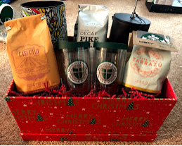

7: Young Einstein:
Discovery Blow Pins Air Brush Set, Discovery Drawing Easel with Markers, Crystal Growing Kit, Volcano Eruption Kit, Glow Dino Excavation Kit, Gem Stone Dig Kit, Smithsonian Rocket, Discovery DIY Soap Making Kit
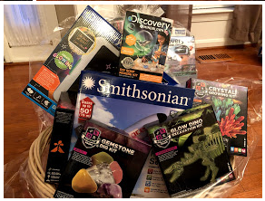

8: Latest from the Lab:
Discovery Solar Robot Creation Kit, Discovery Virtual Reality Head Set, Discovery Rocket Launcher, Smithsonian Magic Rock Kit
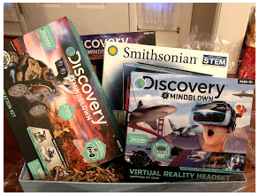

9: An American Girl’s Dream:
American Girl Willa Wellie Wisher Doll, 2 Wellie Wisher Doll Outfits, Mega Construction Doll House featuring Grace, Maddie, and Ella
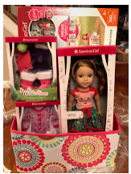

10: Artist Palette:
Marker Set, Colored Pencil Set, Scented Gel Pens, Sketch Book, Hand Lettering Kit, Pastels Set, Scratch Art Kit, Paint with Diamonds Kit, Metallic Markers, Stamps and Ink Pads
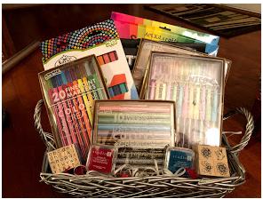

11: Date Night:
Donated in part by The Herbert and Horter Families, Libations, and The American Cancer Society
Bottle of Pinot Noir Rose, $25 Fandango Git Card, $50 Libations Gift Card, Gift Certificate For 2 @Mission Escape Room, One- Night Stay @ Town Place Suites Marriott
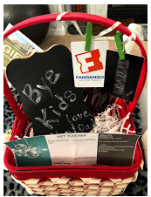

12: Shop ‘Til You Drop:
Puravida Wave Bracelet, $30 Forever 21 Gift Card, $30 Nordstrom’s Gift Card, $30 AE Gift Card,
$25 Ulta Gift Card
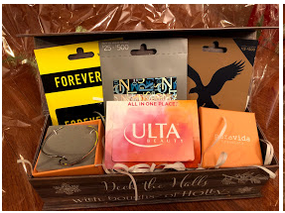

13: Christmas Concert:
4 Front Row Seats (No Waiting in Line), $30 Gift Card to The Grill at Quarterfield
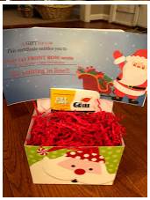

14: Spring Concert:
4 Front Row Seats (No Waiting in Line), $30 Gift Card to Squisito’s.
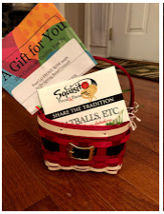

15: Get Fit:
Fitness Tracker with Heart Rate monitor, Water Bottle and Cooling Exercise Towel
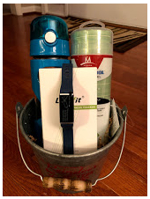

16: Family Game Night!:
Kanoodle, Phase 10, Bananagrams, Charades For Kids, 5 Second Rule, Trivia Pursuit, Family Scavenger Hunt, Movie Candy: Skittles, Hot Tamales, Rainbow Nerds, and Swedish Fish, Popcorn
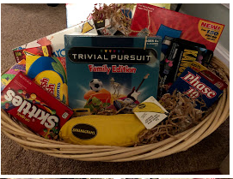

17: We Hope You Win a Lotto!:
$30 in Maryland Scratch Offs, Payday and 100 Grand Candy Bars, 3 Money Flowers ($9 cash)
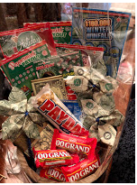

18: Dad Forgot Christmas: Donated by The Moore Family
Pandora Bracelet, Earrings, and a Black Scarf
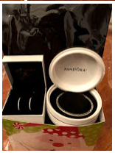

19 Just for Her: Donated by The Moore Family
Pandora Bracelet, Necklace, and a White Scarf.
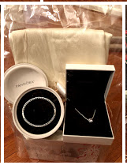

20: Chico’s Bling:
Turquoise Reversible Necklace, Bracelet, Earrings, Black Scarf and Jewelry Tree
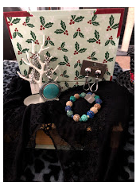

21: Grill Sergeant:
Swivel Grill Brush, 3 Piece Stainless Steel Tool Set, Apron, (2) Non-Stick Grilling Sheets, Grilling Cookbook Barbecue Rub Collection, Digital Thermometer, 2 Pack Cooking Mitts, Set Of 4 Cloth Napkins
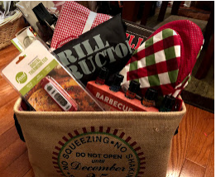

22: Cookies for Santa:
Rolling Pin, Child’s Santa Apron, Cookie Cutter Set, Measuring Cups, Measuring Spoons, Mini Wisk, Cookie Sheet, Cookie Plate, Red, White and Green Cookie Icing, Holiday Sprinkles, Tongs, Oven, Mitts, 2 Old Fashioned Mini Milk Bottles
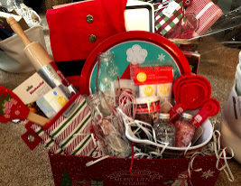

23: Friends 4Ever Sleepover Kit
4 Face Masks, 2 Hand Masks, 2 Foot Masks, Nail Polish, Hair Chalk, Friendship Bracelet Making Kit, 4 Silly String, 4 Cat Ear Headbands
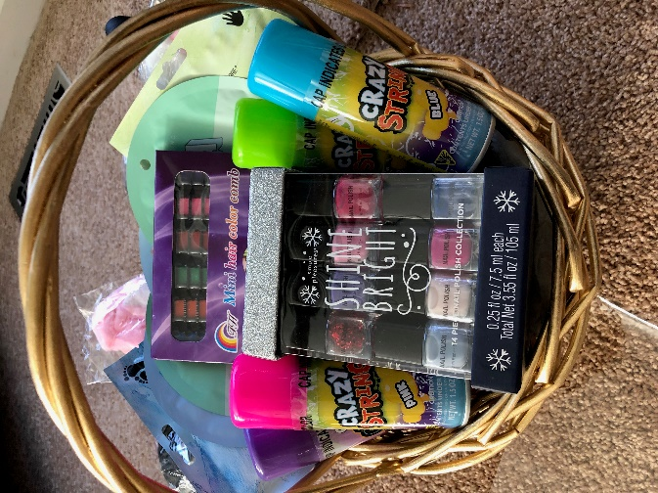

24: For Love of the Game: Donated in part by the Duffey Family
Fortnite Monopoly, Nintendo NES Classic Console, $25.00 Game Stop Gift Card
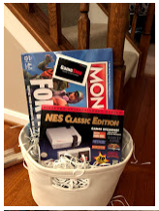

25: Christmas Break Boredom Buster: Donated in part by The Duffey Family
Snowman in A Box, Christmas Window Decorations, Kids Hover Soccer Indoor Toy, Ornament Making Kit, Lego Ninjago Kit, Nativity Scene Craft Kit, Remote Control Car, Super Ball, Giant Felt Build A Scene Tree, Activity Book, Pokemon Model Kit, Pop Advent Calendar
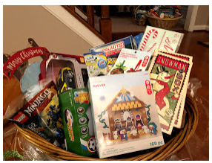

26: Reading Through the Holidays: Donated by Mary Ward
Floppy Plush Puppy Pal, Valentine’s Day Book Pack, Easter Book Pack, Christmas Book Pack, Thanksgiving Book Pack, 4th Of July Book Pack, Scholastic Book Pack
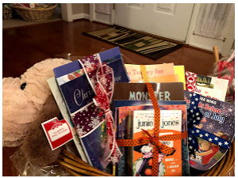

27: Ring in 2019!:
Bottle of Veuve Clicquot Champagne, Bottle of Sparkling White Grape Juice, 4 Champagne Flutes, Noise Makers, Happiness Planner, Birthday and Anniversary Calendar, Photo Props, 4 Confetti Poppers
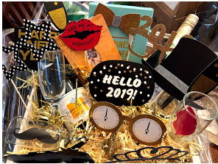

28: I Love My Handy Man:
Stalwart Cordless Drill and Accessories, 32-Ft Laser Level, Gorilla Glue, Gorilla Tape, $25 Home Depot Gift Card, Huskey Tool Caddy
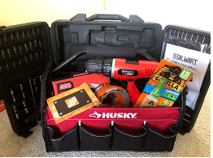

29: Grinning from Ear to Ear: Donated in part by The Sidlowski Family
Ultra Sonic Whitening Tooth Brush, Opalescence Home Teeth Whitening Kit, Sensodyne Tooth Paste
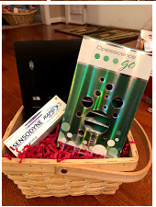

30: Nerf Wars:
2 Disrupter N-Strike Elite Nerf Guns, Additional 30 Pack Nerf Ammo, Ammo Vest and Skeleton Face Mask
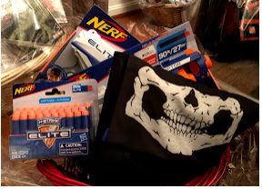

31: Taste of Anne Arundel County:
Donated in part by Mama Lucia’s, The Grill at Quarterfield, and The Horter, Paone, and Herbert Families
Bottle of Chardonnay, 2 Wine Glasses, Cork Container, $50 Gift Card to The Grill at Quarterfield, $50 Olive Grove Gift Card, $25 Mama Lucia Gift Card
