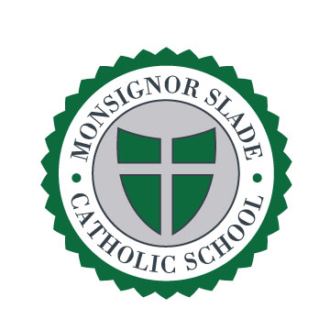
Spring 2016
As another truly successful year at Monsignor Slade Catholic School begins to wind down, we want to take a moment to highlight the accomplishments of which we are most proud. Following the tenets of faith, knowledge, and service daily enables us to realize our mission as a school community.

Throughout the year, we grow in our faith.

We begin and end each day in prayer, and we gather the first day of each week as a school community for student-led prayer services. Practicing our faith daily in acts large and small, we are motivated by our commitment to our Values Code every day. Monthly we gather for Mass and to pray the rosary. Our Rosary Guild students make hundreds of rosaries that are delivered to missions around the world.

Throughout the year, we grow in our knowledge.

Slade was selected by Google as a pilot school to test the development of Google Expeditions and Google Goggles. Students from grades 2-8 were thrilled to be among the first students in the country to test out this cutting edge technology, which promises to revolutionize teaching and learning in schools committed to educating for excellence in the 21st century. We have adopted the Google Apps for Education platform and our students are creating and sharing documents in their classes.

This year, forty-three Slade students in grades 4-8 qualified to participate in Johns Hopkins University Center for Talented Youth based on their outstanding verbal and math 2015 standardized test scores. Additionally, nine students were recently recognized for their essays in the VFW Post 160 Patriots Pen Essay Contest where each wrote on the topic of, “What Freedom Means to Me.”

100% of our students who applied to Catholic high schools were accepted.

Throughout the year, we grow in our service to the greater community.

Slade’s commitment to service is second to none. This year we began with our Shoes for Francis shoe drive honoring Pope Francis’ visit to the United States. While our goal was to collect 2,500 pairs of shoes, we exceeded that number and donated over 5,125 pairs, more than any other school in the Diocese. Our families donated over 800 pounds of toys to the Apopka Mission in Florida for Christmas this year. Each month our families donate homemade lunches to Happy Helpers for the Homeless, totaling over 700 for the year so far. Our Lenten Appeal generated Easter food baskets for members of our community.

Our Patron Saint, St. Julie Billiart, taught that, “We must have courage in the times we live in. Great souls are needed, souls having the interest of God at heart.” It is with courage and conviction that we ask you to support this year’s Annual Giving Appeal, which enables us to continue realizing the mission and goals of Monsignor Slade Catholic School. Thank you in advance for your investment and confidence in the future growth of our school.

Sincerely,

Alexa Cox Tom Jester
Principal School Board Chair

